Screen Layouts

Layout 1 below shows what an administrator might wee when creating, editing, or deleting a survey. The form offers many different types of questions, as well as a button to add more questions. The administrator basically has free range to go in and put whatever they need into the survey.



Layout 2 below shows what an administrator might see when creating an event. There are text boxes used to enter in event information. There is also a calendar that can be used to select the date. This will help with validation and make it a bit easier to select the date. There is also a section to add any relevant pictures that will show up in the events widget.



.

Layout 3 below shows what an administrator might see when editing and deleting an event. The first widget is used to quickly delete an event by clicking the ‘x’ button on the right-hand side of each event. The other symbol is used to edit an event. It will let the administrator edit the event title. The second image is the event editor. It is a more detailed editor that lets the administrator make sweeping changes to an event.



Layout 4 below is what a user would see if they were to fill out an industry request form. This is nearly identical to the existing IR form that exists on the site now. It didn’t need much changing.



Layout 5 below shows how users can RSVP for an event as well as cancel for an event. If logged in, the user will simply click RSVP and that is it. The button will switch to say cancel to give them that option in the future. If the user has no account, they will be prompted to enter some information so that they can be added as an event attendee.



Layout 5

Create announcement

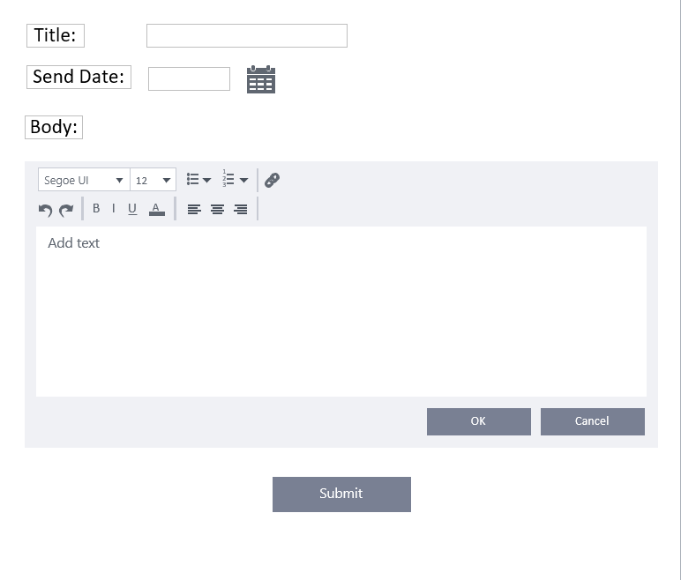

Layout 6

Create Grant

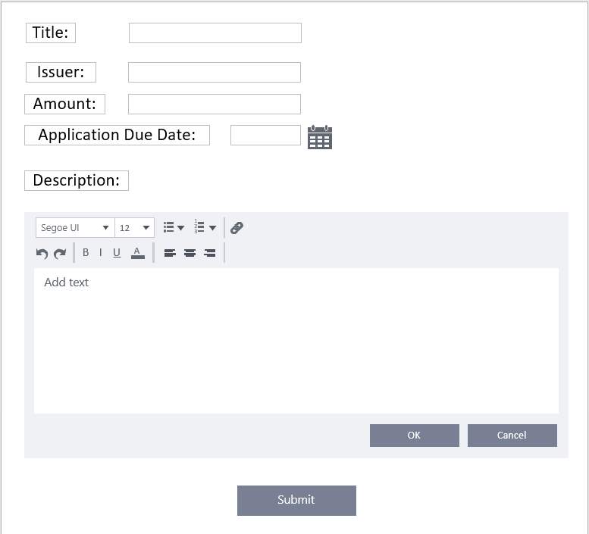

Layout 7

Create Newsletter

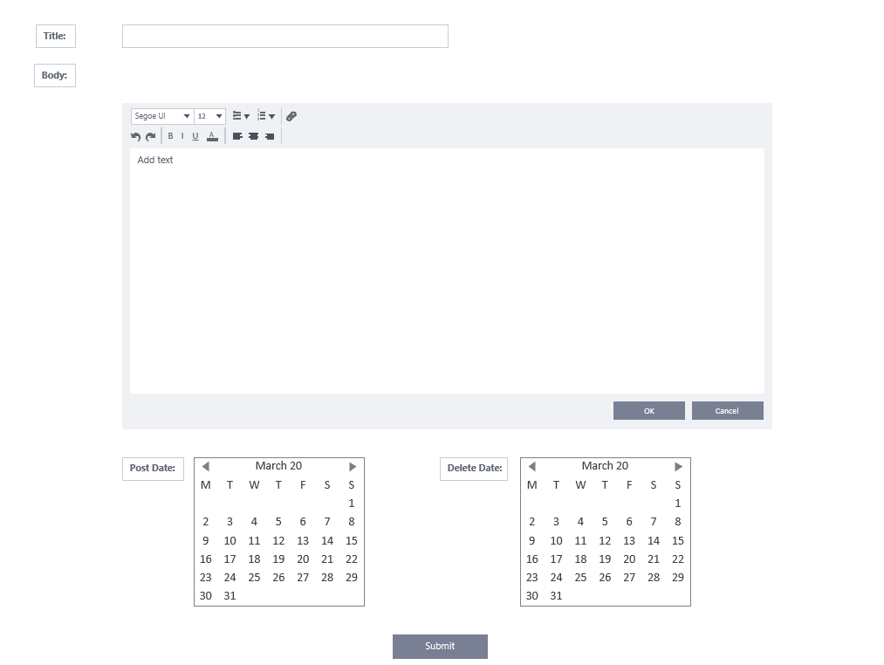

Layout 8

Create user profile

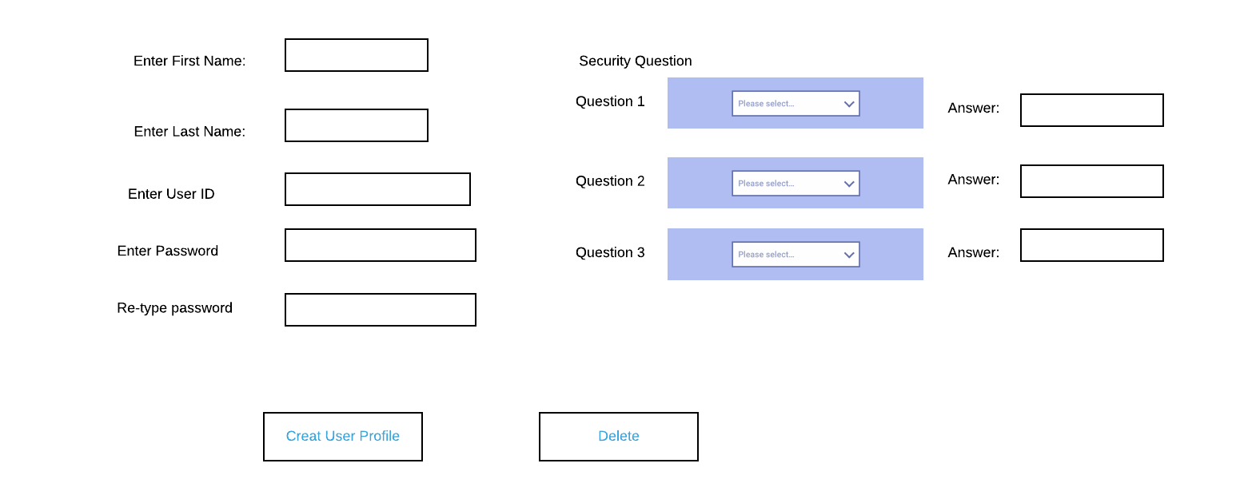

Layout 9

This prototype demonstrates the contact us form that students and visitors can use to contact the Office of Research and Innovation.

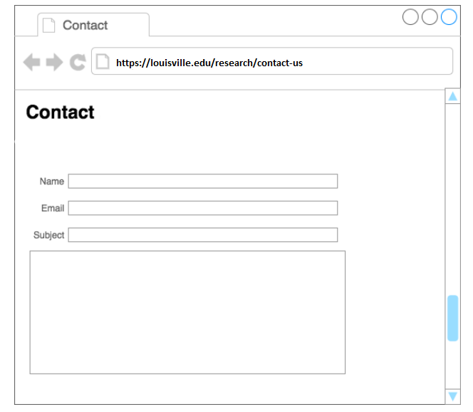

Layout 10

This Prototype demonstrates what an administrator interface looks like when accessing the admin portal.

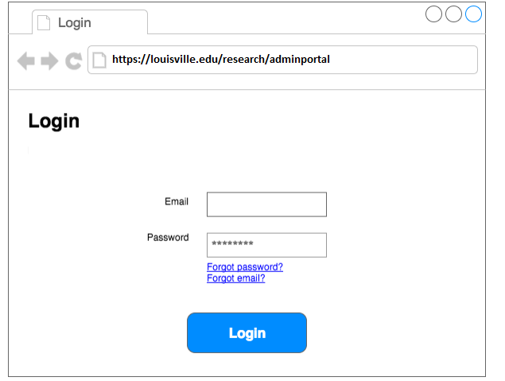

Layout 11

Submit Proposal

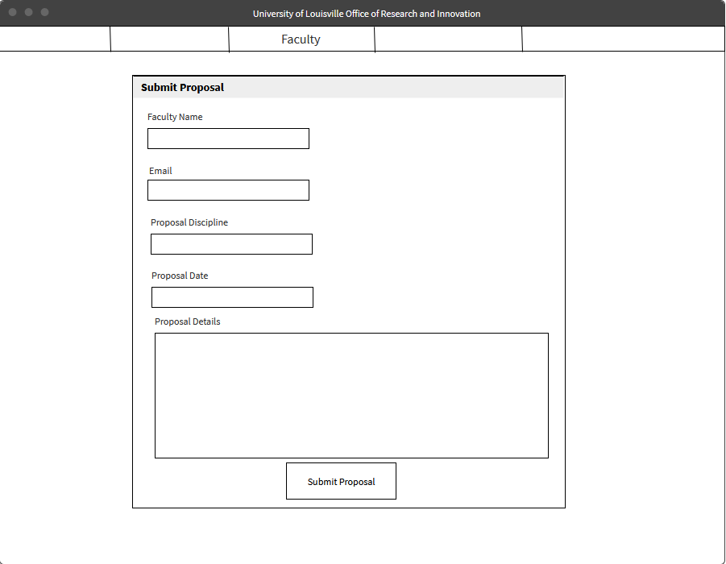

Layout 12

Statistics Interface

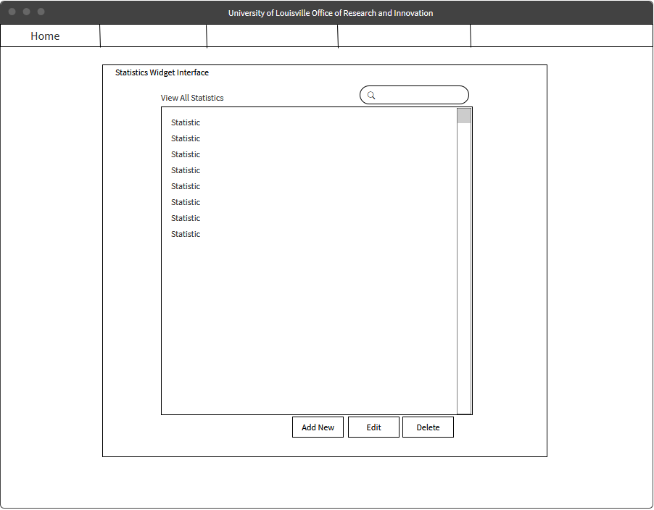

Layout 13

Edit Statistic

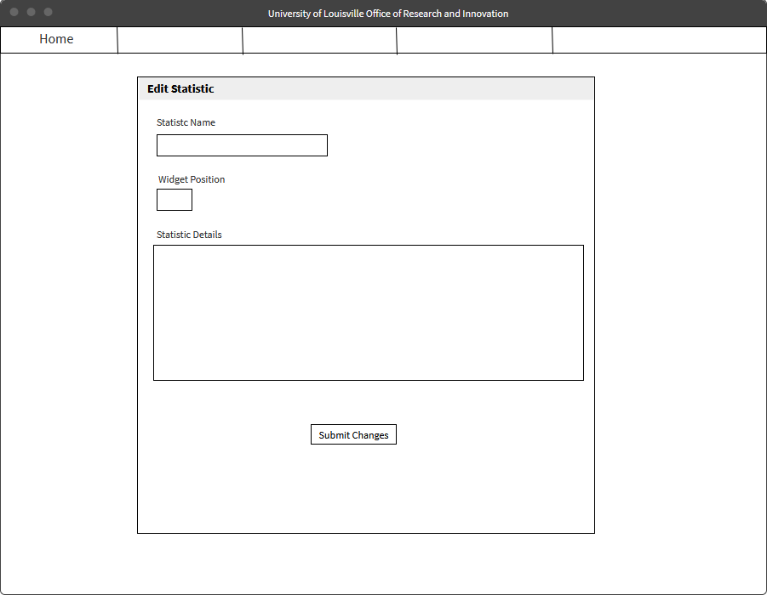

Layout 14

Edit Industry Proposal

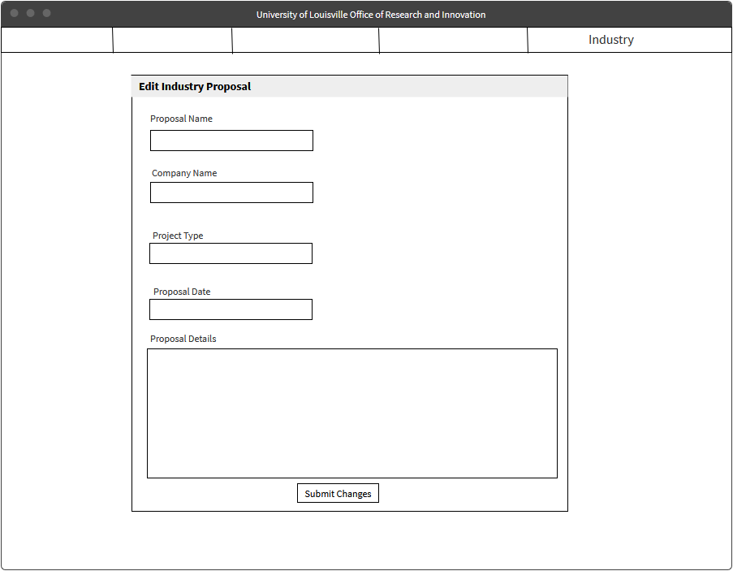

Layout 15

Apply for newsletter

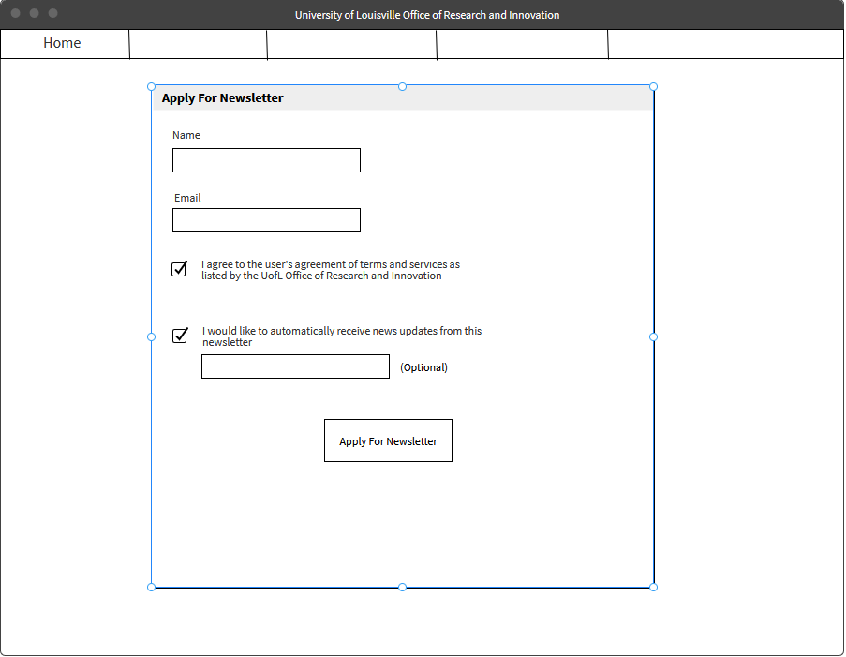

Layout 16

Apply for grant

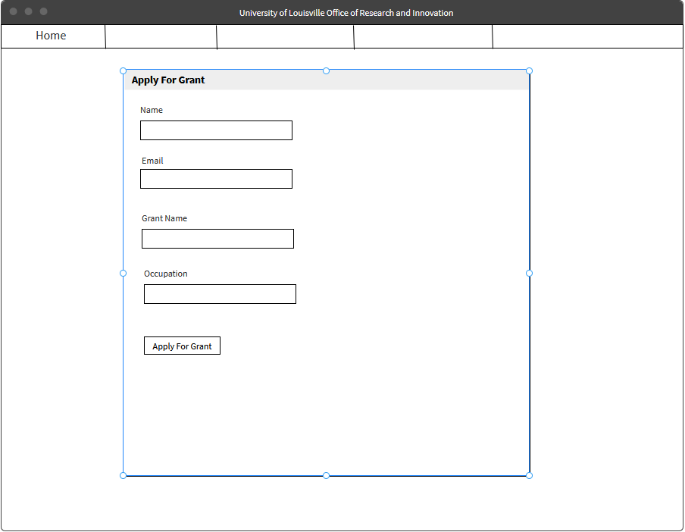

Layout 17

View proposals

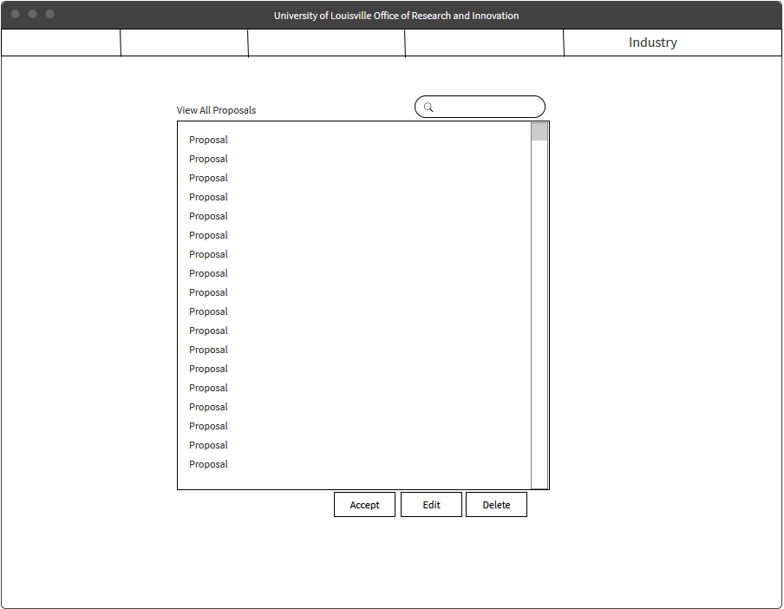

Layout 18